FLEXI KUPANG COMMUNITY

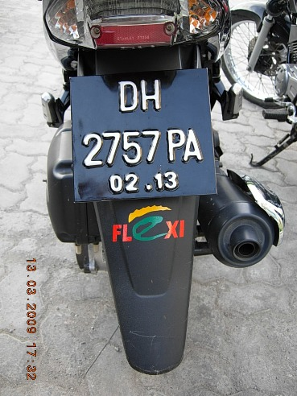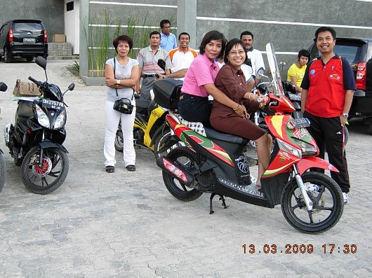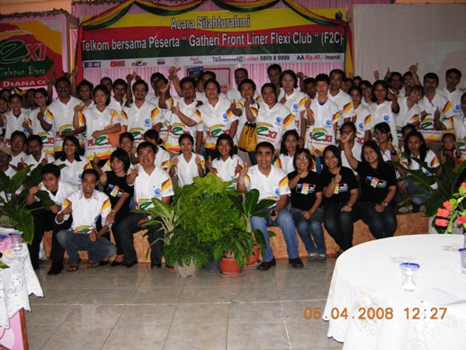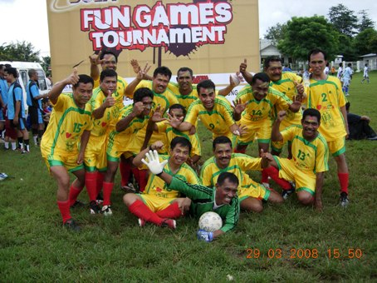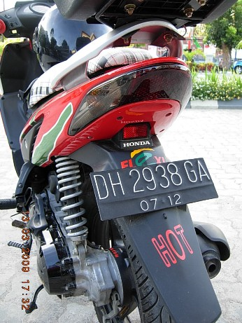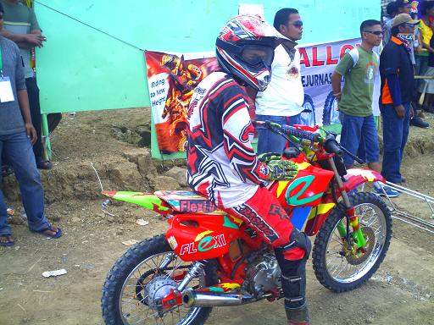

Nowadays, almost all the practical areas of community life there, starting from a very serious until just an awareness of a product or certain classes of emotional similarity. Moreover, driven by rapid progress in information technology, especially with the more global usage of the Internet and the smart phone.
With the condition that limited campaign funds and including costs for special use to the community, and Datel does not Kupang of mind with the creativity of the human resources are also utilized the strength of the group to have more interest in addition to the product, Telkom is not in love with the direct product of the service itself, with their voluntary membranding property owned by Telkom with the product.
Telkom’s Internal Community includes:

- Club
- Progressive Community: a discussion about marketing

Hopefully with an emotional connection we invite new members of militant and a new community that use and love the products of Telkom.

Zero cost high impact. @win-kpg

